**The National Institute of Engineering**

(An Autonomous Institution under Visvesvaraya Technological University, Belagavi)

#### Mysuru-570008



DISSERTATION ON

**“VISIBLE LIGHT COMMUNICATION BASED FILE DELIVERY SYSTEM”**

Submitted in partial fulfillment for the award of

BACHELOR OF ENGINEERING IN

**“ELECTRONICS AND COMMUNICATION”**

For the academic year 2018-2019

#### Submitted by:

**AKHILESH C GUDDAD 4NI15EC008**

**ASHWIN T R 4NI15EC022**

**BASAVARAJ R SUNAGAD 4NI15EC025**

**MANAV GURUMOORTHY 4NI15EC056**

**Under the guidance of**

**Dr. Rohini Nagapadma**

**Professor, Dept. of ECE**

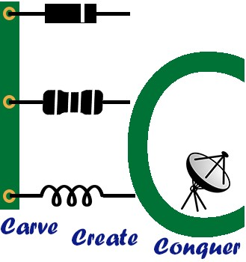

**THE NATIONAL INSTITUTE OF ENGINEERING**

**Department of Electronics and Communication Engineering Mysuru- 570008.**

**2018-2019**

**THE NATIONAL INSTITUTE OF ENGINEERING**

# Department of Electronics and Communication

### Mysuru -570008.



**CERTIFICATE**

This is to certify that the project entitled **“VISIBLE LIGHT COMMUNICATION BASED FILE DELIVERY SYSTEM”** has been successfully completed by **AKHILESH C GUDDAD (4NI15EC008),** **ASHWIN T R (4NI15EC022),** **BASAVARAJ R SUNAGAD (4NI15EC025),** **MANAV GURUMOORTHY (4NI15EC056)** of 8th semester B.E. who carried out the project work under guidance of **“DR. ROHINI NAGAPADMA”** in the Partial fulfillment for the award of degree of Bachelor Engineering in Electronics and Communication Engineering of Visvesvaraya Technological University, Belagavi during the year 2018-19. It is certified that all corrections/Suggestions indicated during internal assessment have been incorporated in the report. The Project has been approved in partial fulfillment for the award of the said degree as per academic regulations of the National Institute of Engineering (An Autonomous Institution under Visvesvaraya Technological University, Belagavi).

#### Dr.Rohini Nagapadma,

**Ph.D.,**

Project Guide,

Department of ECE

#### Name of the Examiner

#### 1.

#### 2.

#### Dr.Rohini Nagapadma,

**Ph.D.,**

Head of the Department, Department of ECE

**Dr. G Ravi**

**Ph.D.,**

Principal

NIE, Mysuru

**Signature with date**

**ACKNOWLEDGEMENT**

We would like to take this opportunity to express our sincere gratitude and respect to those who helped us during the different stages of the project.

We sincerely extend our thanks to our guide **Dr. Rohini Nagapadma,** Head of the Department, Electronics and Communication Engineering, NIE Mysore, for her valuable guidance, constant assistance and support for the betterment of this project.

We also extend our heartfelt thanks to all non–teaching staff who helped us by providing required equipment and necessary materials to complete this project.